
A
REPORT OF MINI PROJECT
ON
“Library Management System ”
Submitted To
Computer Science and Technology, Department of Technology
Shivaji University, Kolhapur

Library Management System
Submitted By
ROLL NO. | NAME | PRN NO.
09 | Vardatta R. Deshpande | 2024075092
12 | Aniket M. Gavade | 2024076132
08 | Vaishnav B. Chine | 2024075307
16 | Sahil K. Jadhav | 2024075119

Under the Guidance of
Prof.Amarja Bhosale
Computer Science & Technology, Department of Technology
Shivaji University, Kolhapur
2025-26
CERTIFICATE

Shivaji University, Kolhapur
Mini Project report
Has been successfully completed by
Mr. ____________________________
I satisfactorily completed a mini project report on "Library Management System " under the guidance of Prof. Amarja Bhosale towards fulfilment of B.Tech. (Computer Science & Technology) Semester III of Department of Technology, Shivaji University, Kolhapur.
Guide Co-Ordinator
Prof. Amarja Bhosale Prof.Amarja Bhosale
Date: ____________
Place: Kolhapur

DECLARATION

I hereby declare that the Mini Project entitled “Library Management System ” is completed and written by me and has not previously formed the basis for the award of any Degree or Diploma or other similar title of this or any other University or examining body.
Date: ____________
Place: Kolhapur
Student Name:
Mr. ____________________________

ACKNOWLEDGEMENT

During the selection and implementation of the topic entitled “Library Management System ”, the help I received from my professors, family and friends is invaluable and I am deeply thankful to them.
I would like to express my sincere gratitude to my mini project guide Prof. Amarja Bhosale and the HOD of Computer Science and Technology Dr. R. J. Deshmukh for their continuous support, suggestions, encouragement and interest in my mini project work.
I also thank all teaching and non-teaching staff of the department for providing the necessary facilities and a positive environment for the successful completion of this work.
Last but not least, I would like to thank my friends and parents for their constant support and motivation.
SUBMITTED BY –
Mr. ____________________________
Academic Year 2025-26
Place: Kolhapur

Report Details

Mini Project Title : Library Management System
Domain : / GUI-based And Web-Based Desktop Web App
Language/Tools : Python, Tkinter, Tkinter Dialogs (messagebox, simpledialog), VS Code / IDLE

ABSTRACT

The Library Management System using Python (Tkinter) is a desktop application that helps colleges and small institutes maintain records of books and their availability in a simple and organized manner. The system replaces manual register-based work with an interactive graphical user interface that supports adding books, removing books, searching books, borrowing books and returning books.
The application is implemented using Python with Tkinter for the GUI. All book records are maintained in an in-memory list of dictionaries and are displayed in a text area with a scroll bar. Dialog boxes are used for user input (such as book title and author) and for informative success or error messages. The design can be extended to use persistent storage such as JSON files or SQLite database if required.
This mini project demonstrates event-driven programming, GUI design, modular functions and basic data handling in Python. It forms a good foundation for further development into a full-featured library system that includes member management, due dates, fines and detailed reporting.

INDEX

1. INTRODUCTION
2. LITERATURE REVIEW
3. OBJECTIVES
4. SYSTEM ARCHITECTURE AND FLOW
5. MODULE DESCRIPTION
6. ALGORITHM
7. SAMPLE CODE (PYTHON – TKINTER)
8. TECHNOLOGIES USED
9. DATA DESIGN
10. RESULT
11. USES
12. CONCLUSION
13. REFERENCES
14. OUTPUT

INTRODUCTION

Libraries provide access to knowledge resources such as books, magazines and other reading material. Many small libraries still depend on paper registers or basic spreadsheets to track the books they own and the books that are currently issued. These manual methods are time-consuming, difficult to update and prone to errors.
A library management system automates these routine tasks. The system designed in this mini project focuses on a simple book-centric view of the library. It allows the librarian to add new books with title and author, remove books, search any particular book and record whether a book is available or borrowed. All interaction is performed using a graphical interface created with Python's Tkinter library.
Key Features of the implemented system:
• Add a new book with title and author using a dialog box.
• Remove an existing book from the list.
• Search a book by its title and view its status (Available / Borrowed).
• Display all books in a scrollable text area with status information.
• Borrow a book (mark as not available).
• Return a book (mark as available again).
• Status bar showing the total number of books in the system.

LITERATURE REVIEW

Over the years, library automation has moved from traditional card catalogues to fully computerized systems. Complete integrated library management systems such as Koha are widely used in large institutions. These systems manage acquisition, cataloguing, circulation and reporting using client-server or web-based architectures.
For academic mini projects and department-level libraries, lightweight custom applications are often preferred. Python is a suitable language for this purpose because of its readability and rich standard library. Tkinter, the standard GUI package for Python, makes it possible to design windows, buttons, labels and dialogs with comparatively less code.
Most reference examples of library management projects in Python focus either on command-line interaction or on web frameworks such as Django and Flask. This mini project focuses specifically on a Tkinter-based desktop application with a clean interface similar to real-world applications. The layout uses a header, a left-side menu and a central display area for listing books.

OBJECTIVES

• To design a user-friendly desktop-based Library Management System using Python Tkinter.
• To understand and implement event-driven GUI programming concepts.
• To manage book records (add, remove, search, borrow, return) in an organized way.
• To provide a visual status of books using a scrollable text area and status bar.
• To practice modular programming using separate functions for each menu operation.
• To create a mini project that can be further extended with persistent storage and student records.

SYSTEM ARCHITECTURE AND FLOW

The system is based on a simple modular architecture with three main layers: user interface layer, application logic layer and data layer.
1. User Interface Layer:
Implemented using Tkinter. The main window contains a blue header with the project title, a grey sidebar showing menu buttons (Add Book, Remove Book, Search Book, Display All, Borrow Book, Return Book, Quit) and a central area showing the list of books. Dialog boxes (simpledialog and messagebox) are used for user input and feedback messages.
2. Application Logic Layer:
This layer is implemented as methods in the LibraryManagementSystem class. Each button is connected to a specific method that performs validation, manipulates the in-memory data and updates the user interface accordingly.
3. Data Layer:
Book records are stored in a Python list of dictionaries. Each dictionary stores the title, author and availability of a book. The current implementation keeps this data in memory while the application is running. The design can be easily extended to use JSON or a database for permanent storage.
Basic Flow of Operations:
• User starts the application and the main Tkinter window is displayed.
• User selects an operation from the menu on the left (for example, Add Book).
• For Add / Remove / Search / Borrow / Return operations, a dialog box asks for the book title (and author for Add).
• The corresponding method performs the operation on the internal list of books.
• A success or error messagebox is displayed based on the result.
• Display All updates the central text area with the current details of every book.
• The status bar at the bottom is updated with the latest total number of books.

MODULE DESCRIPTION

1. Add Book Module:
Prompts the user to enter the title and author of a book. On confirmation, a new dictionary containing the book details and availability status is appended to the books list. A success message is displayed and the status bar is updated.
2. Remove Book Module:
Asks for the title of the book to remove. The system searches the books list and, if a matching title is found, removes that book. If the book does not exist, an error message is displayed.
3. Search Book Module:
Allows the user to search a book by its title. If found, a messagebox shows the book title, author and current status (Available / Borrowed). If not found, an appropriate message is displayed.
4. Display All Module:
Clears the text area and prints a formatted list of all books with their title, author and status. This gives a quick overview of the library contents.
5. Borrow Book Module:
Prompts the user for a book title. If the book exists and is currently available, the module marks it as borrowed (available = False) and shows a success message. If the book is already borrowed, an error message is displayed.
6. Return Book Module:
Similar to Borrow Book, but reverses the status. If the specified book exists and is currently borrowed, it marks the book as available again. Otherwise an informative message is shown.

ALGORITHM
1. Start
2. Read the book title from the input dialog.
3. If title is empty, display error message and stop.
4. Search the list of books for a dictionary whose title matches (case-insensitive).
5. If no such book is found, display 'Book not found' message and stop.
6. If book is found and its available flag is False, display 'Book already borrowed' message and stop.
7. If book is found and available flag is True, set available = False.
8. Update the status label showing total number of books (optional).
9. Display success message 'Book borrowed successfully'.
10. End.

SAMPLE CODE
import tkinter as tk
from tkinter import messagebox, simpledialog, ttk
class LibraryManagementSystem:
def __init__(self, root):
self.root = root
self.root.title("Library Management System")
self.root.geometry("800x600")
self.root.configure(bg="#e8f4f8") # Light blue background for a library theme
# In-memory storage for books: list of dicts with title, author, available status
self.books = []
# Style configuration for ttk widgets
style = ttk.Style()
style.configure("TButton", font=("Arial", 10), padding=5)
style.configure("TLabel", font=("Arial", 12), background="#e8f4f8")
style.configure("Header.TLabel", font=("Arial", 20, "bold"), foreground="#2c3e50", background="#e8f4f8")
# Main container
main_frame = tk.Frame(root, bg="#e8f4f8")
main_frame.pack(fill=tk.BOTH, expand=True)
# Header section
header_frame = tk.Frame(main_frame, bg="#3498db", height=100) # Blue header
header_frame.pack(fill=tk.X, side=tk.TOP)
header_frame.pack_propagate(False)
logo_label = ttk.Label(header_frame, text="📚 Library Management System", style="Header.TLabel")
logo_label.pack(pady=30)
# Content frame (split into sidebar and main area)
content_frame = tk.Frame(main_frame, bg="#e8f4f8")
content_frame.pack(fill=tk.BOTH, expand=True)
# Sidebar for buttons
sidebar_frame = tk.Frame(content_frame, bg="#bdc3c7", width=200) # Gray sidebar
sidebar_frame.pack(side=tk.LEFT, fill=tk.Y)
sidebar_frame.pack_propagate(False)
sidebar_title = ttk.Label(sidebar_frame, text="Menu", font=("Arial", 14, "bold"))
sidebar_title.pack(pady=10)
self.add_button = ttk.Button(sidebar_frame, text="➕ Add Book", command=self.add_book)
self.add_button.pack(pady=5, fill=tk.X, padx=10)
self.remove_button = ttk.Button(sidebar_frame, text="➖ Remove Book", command=self.remove_book)
self.remove_button.pack(pady=5, fill=tk.X, padx=10)
self.search_button = ttk.Button(sidebar_frame, text="🔍 Search Book", command=self.search_book)
self.search_button.pack(pady=5, fill=tk.X, padx=10)
self.display_button = ttk.Button(sidebar_frame, text="📋 Display All", command=self.display_books)
self.display_button.pack(pady=5, fill=tk.X, padx=10)
self.borrow_button = ttk.Button(sidebar_frame, text="📖 Borrow Book", command=self.borrow_book)
self.borrow_button.pack(pady=5, fill=tk.X, padx=10)
self.return_button = ttk.Button(sidebar_frame, text="🔄 Return Book", command=self.return_book)
self.return_button.pack(pady=5, fill=tk.X, padx=10)
self.quit_button = ttk.Button(sidebar_frame, text="❌ Quit", command=root.quit)
self.quit_button.pack(pady=20, fill=tk.X, padx=10)
# Main display area
display_frame = tk.Frame(content_frame, bg="#e8f4f8")
display_frame.pack(side=tk.RIGHT, fill=tk.BOTH, expand=True, padx=20, pady=20)
display_title = ttk.Label(display_frame, text="Book List & Details")
display_title.pack(pady=5)
# Text area with scrollbar
text_frame = tk.Frame(display_frame)
text_frame.pack(fill=tk.BOTH, expand=True)
self.text_area = tk.Text(text_frame, height=15, width=60, font=("Courier", 10), bg="#ffffff", fg="#2c3e50", relief=tk.SUNKEN, bd=2)
scrollbar = tk.Scrollbar(text_frame, command=self.text_area.yview)
self.text_area.config(yscrollcommand=scrollbar.set)
self.text_area.pack(side=tk.LEFT, fill=tk.BOTH, expand=True)
scrollbar.pack(side=tk.RIGHT, fill=tk.Y)
# Footer status bar
footer_frame = tk.Frame(main_frame, bg="#34495e", height=30) # Dark blue footer
footer_frame.pack(fill=tk.X, side=tk.BOTTOM)
footer_frame.pack_propagate(False)
self.status_label = ttk.Label(footer_frame, text="Ready. Total books: 0", foreground="white", background="#34495e")
self.status_label.pack(pady=5)
# Update status on init
self.update_status()
def update_status(self):
self.status_label.config(text=f"Ready. Total books: {len(self.books)}")
def add_book(self):
title = simpledialog.askstring("Add Book", "Enter book title:")
author = simpledialog.askstring("Add Book", "Enter author name:")
if title and author:
self.books.append({"title": title, "author": author, "available": True})
messagebox.showinfo("Success", f"Book '{title}' added successfully!")
self.update_status()
else:
messagebox.showerror("Error", "Title and author are required.")
def remove_book(self):
title = simpledialog.askstring("Remove Book", "Enter book title to remove:")
if title:
for book in self.books:
if book["title"].lower() == title.lower():
self.books.remove(book)
messagebox.showinfo("Success", f"Book '{title}' removed successfully!")
self.update_status()
return
messagebox.showerror("Error", f"Book '{title}' not found.")
else:
messagebox.showerror("Error", "Title is required.")
def search_book(self):
title = simpledialog.askstring("Search Book", "Enter book title to search:")
if title:
for book in self.books:
if book["title"].lower() == title.lower():
status = "Available" if book["available"] else "Borrowed"
messagebox.showinfo("Book Found", f"Title: {book['title']}\nAuthor: {book['author']}\nStatus: {status}")
return
messagebox.showerror("Error", f"Book '{title}' not found.")
else:
messagebox.showerror("Error", "Title is required.")
def display_books(self):
self.text_area.delete(1.0, tk.END)
if not self.books:
self.text_area.insert(tk.END, "No books in the library.\n")
else:
for book in self.books:
status = "Available" if book["available"] else "Borrowed"
self.text_area.insert(tk.END, f"📖 Title: {book['title']}, Author: {book['author']}, Status: {status}\n")
def borrow_book(self):
title = simpledialog.askstring("Borrow Book", "Enter book title to borrow:")
if title:
for book in self.books:
if book["title"].lower() == title.lower():
if book["available"]:
book["available"] = False
messagebox.showinfo("Success", f"Book '{title}' borrowed successfully!")
self.update_status()
else:
messagebox.showerror("Error", f"Book '{title}' is already borrowed.")
return
messagebox.showerror("Error", f"Book '{title}' not found.")
else:
messagebox.showerror("Error", "Title is required.")
def return_book(self):
title = simpledialog.askstring("Return Book", "Enter book title to return:")
if title:
for book in self.books:
if book["title"].lower() == title.lower():
if not book["available"]:
book["available"] = True
messagebox.showinfo("Success", f"Book '{title}' returned successfully!")
self.update_status()
else:
messagebox.showerror("Error", f"Book '{title}' was not borrowed.")
return
messagebox.showerror("Error", f"Book '{title}' not found.")
else:
messagebox.showerror("Error", "Title is required.")
# Run the application
if __name__ == "__main__":
root = tk.Tk()
app = LibraryManagementSystem(root)
root.mainloop()

TECHNOLOGIES USED
1. Python Programming Language
Used for implementing application logic and data structures.
2. Tkinter
Used for creating the graphical user interface, dialogs and widgets.
3. Tkinter.ttk
Used for modern themed buttons, labels and styling.
4. Development Environment
Visual Studio Code / IDLE with Python interpreter.

*DATA DESIGN
The current implementation uses an in-memory structure to store books. Each book is represented as a Python dictionary with the following keys:
• title – Title of the book.
• author – Name of the author.
• available – Boolean flag indicating whether the book is available or borrowed.
All these book dictionaries are stored in a list named books. This design is simple and sufficient for a mini project. For long-term use, the same structure can be serialized into a JSON file or mapped to a relational database table with fields (book_id, title, author, status).

RESULT
After implementing and testing the Library Management System using Python Tkinter, the following results were observed:
• The main window with sidebar menu and central display area is user-friendly and responsive.
• Books can be successfully added, removed, borrowed and returned with appropriate success messages.
• The system correctly prevents borrowing a book that is already borrowed.
• Search operation accurately finds books by title and displays their status.
• The display area lists all stored books with their current availability.
• The status bar at the bottom always shows the correct total number of books.

*USES
• Useful for small libraries, reading rooms or personal collections where a quick desktop tool is needed.
• Helps students understand GUI programming concepts in Python using Tkinter.
• Can be used as a base project for adding more advanced features like member records and fine calculations.
• Provides a practical demonstration for mini project evaluation and viva voce.

CONCLUSION

- The Library Management System using Python (Tkinter) meets its basic objectives by automating common library operations in a simple, interactive desktop application. The system demonstrates how GUI programming, data structures and modular design can be combined to create a functional mini project.
- Future improvements may include student management, persistent storage using JSON or SQLite, tracking issue and return dates, calculating fines and exporting reports. The current design and code structure already provide a solid base to incorporate these enhancements.

REFERENCES

1. Python Official Documentation – https://docs.python.org/
2. Tkinter Reference – effbot.org / TutorialsPoint / GeeksforGeeks articles.
3. Various online examples of Python Tkinter projects and GUI layouts.
4. Class notes and material from Computer Science & Technology Department.
5.Research Paper form Research Guide - https://www.researchgate.net/publication/347245735_Library_Management_System

OUTPUT

The following screenshots show the working of the Library Management System application. Each screenshot is placed on a separate page for clarity.

Home screen with menu and empty book list.
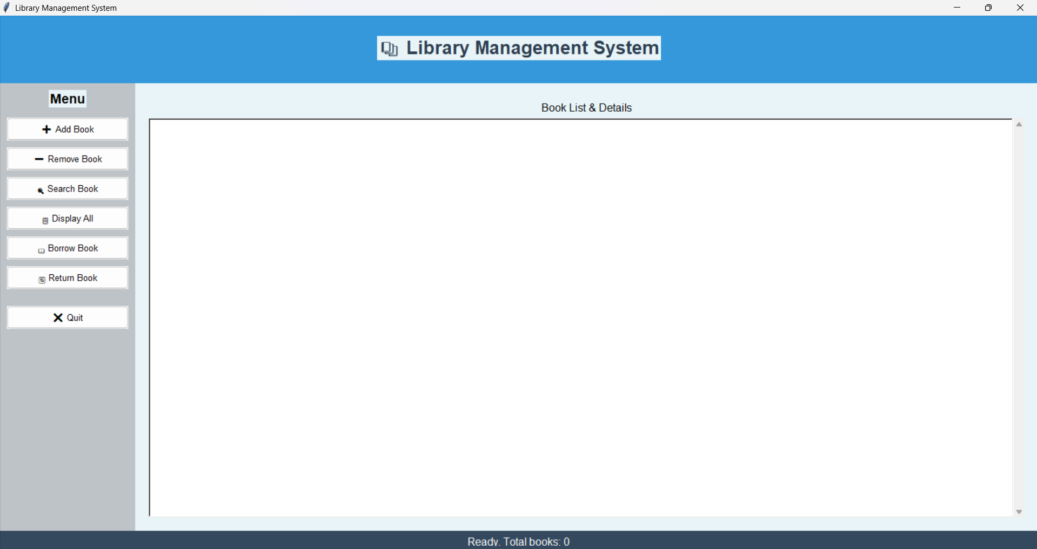

Add Book dialog asking for book title.
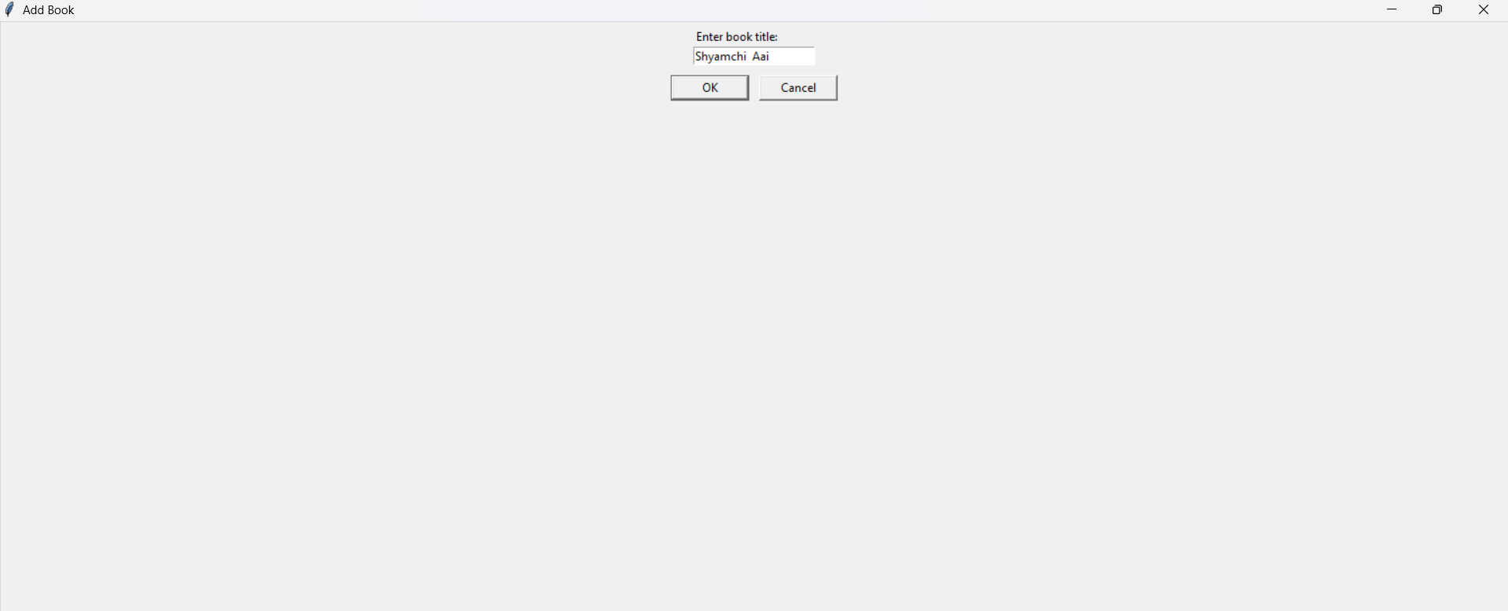

Remove Book dialog asking for book title to remove.
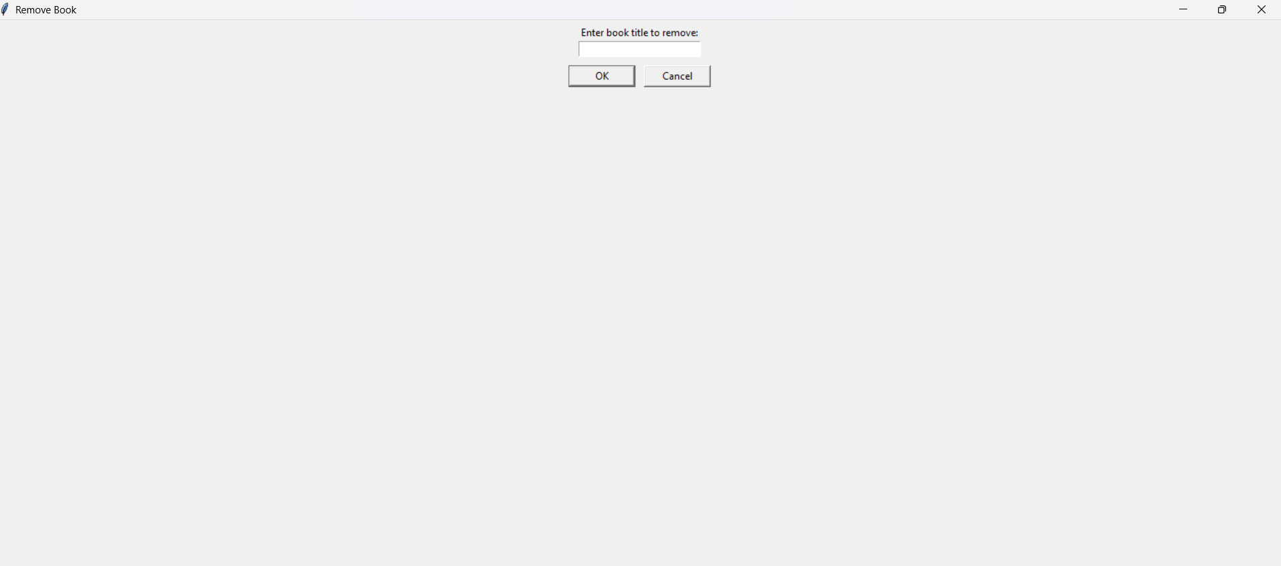

Search Book dialog to search a book by title.
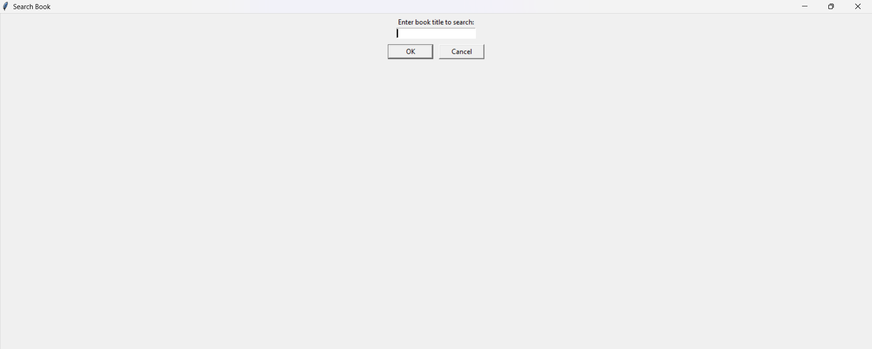

Borrow Book dialog while borrowing a book.
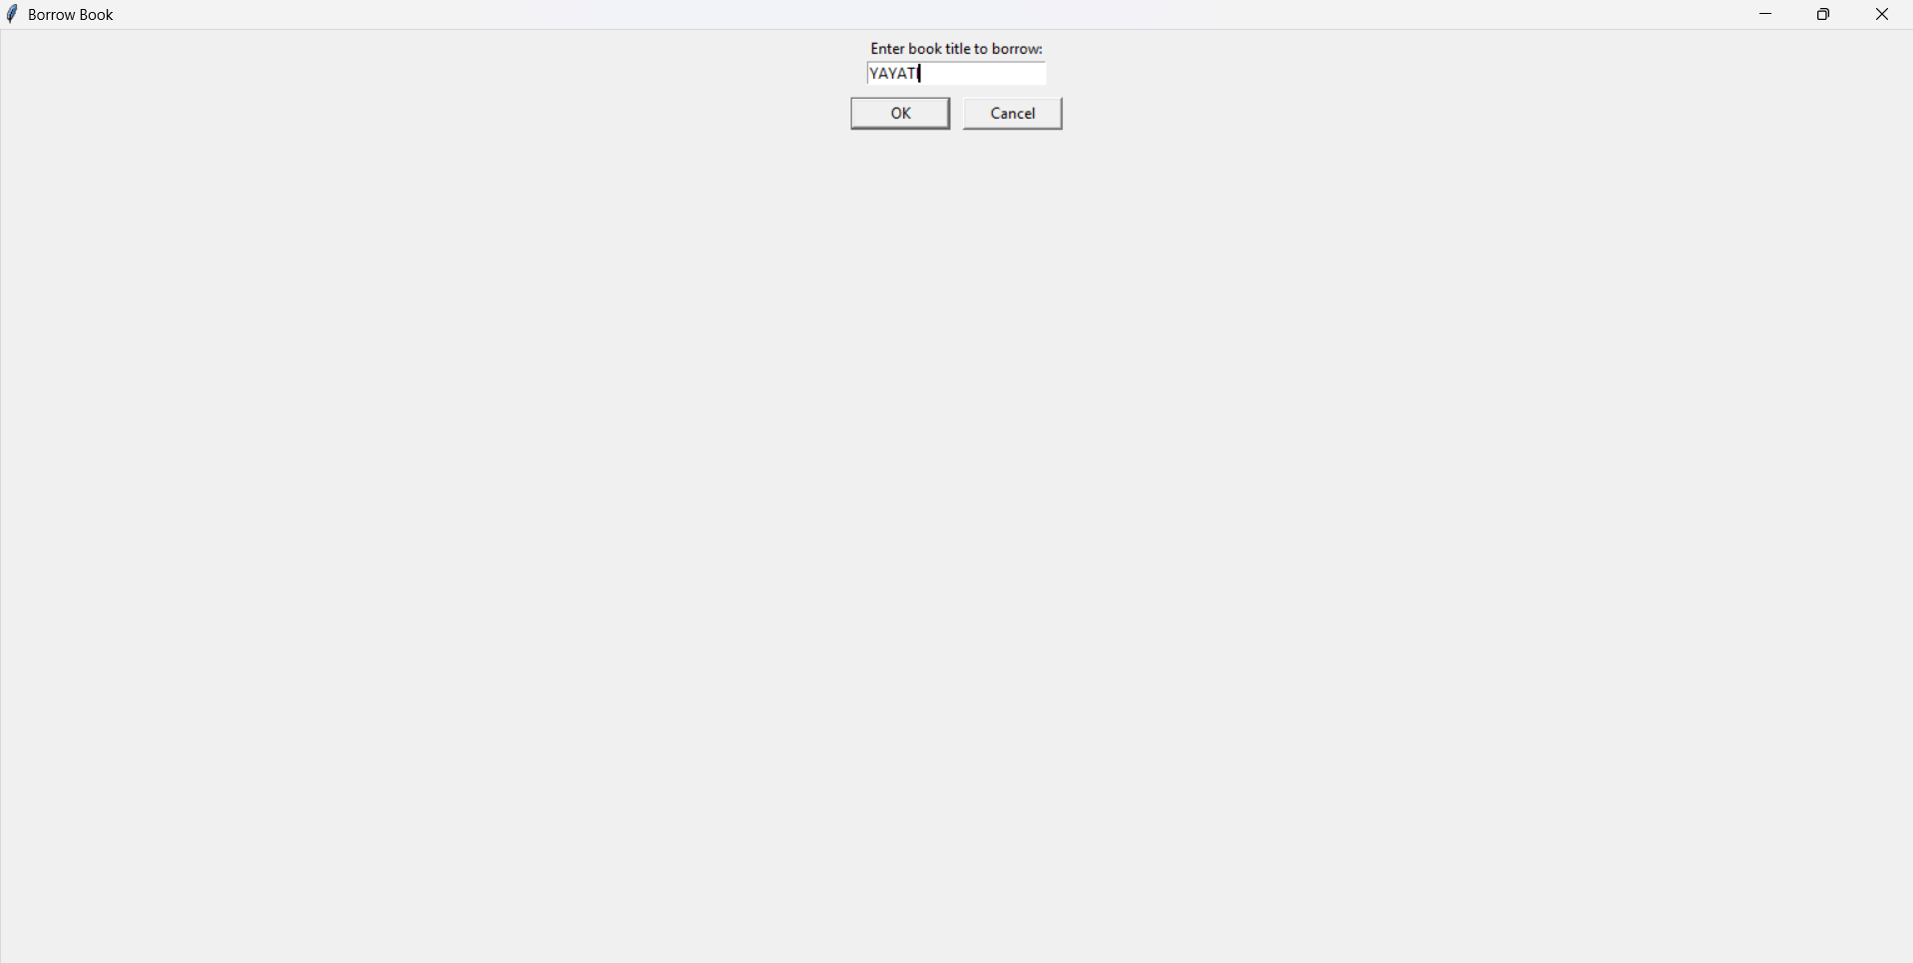

Return Book dialog while returning a book.
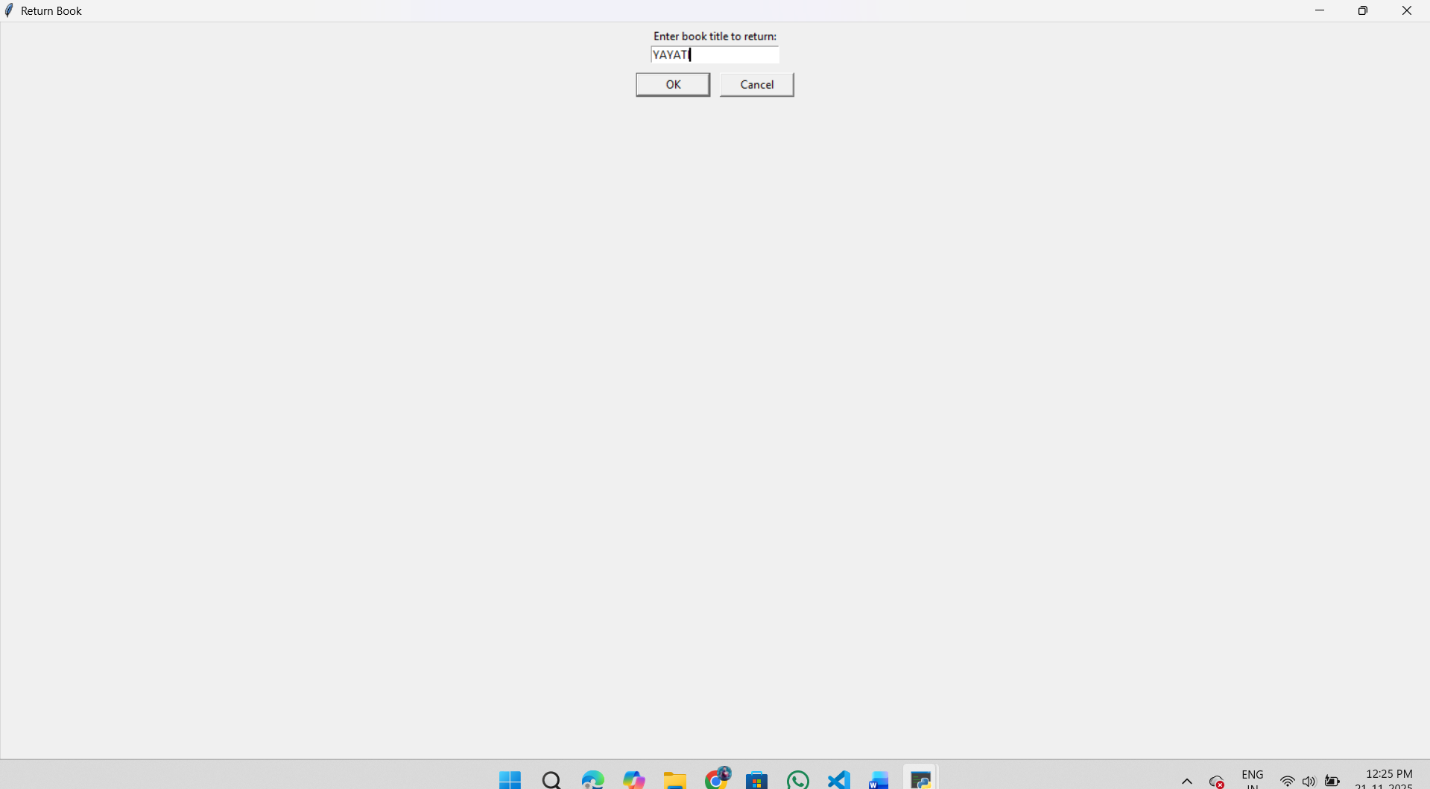

Success message: book returned successfully.
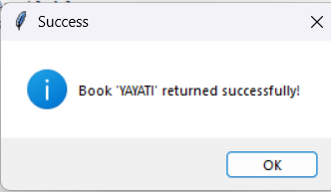

Additional success / information popup from the system.

ADDITIONAL OUTPUT (VALIDATION, STATUS AND DETAILED VIEW)

The following additional screenshots highlight validation messages, successful operations and the final list of books in the system. Each image demonstrates how the application responds to user actions.

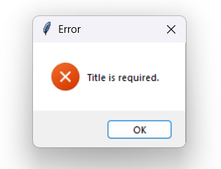
Validation error message when the user leaves the title field empty.

Success message showing that the book 'YAYATI' has been borrowed successfully.
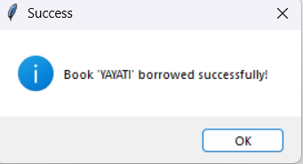

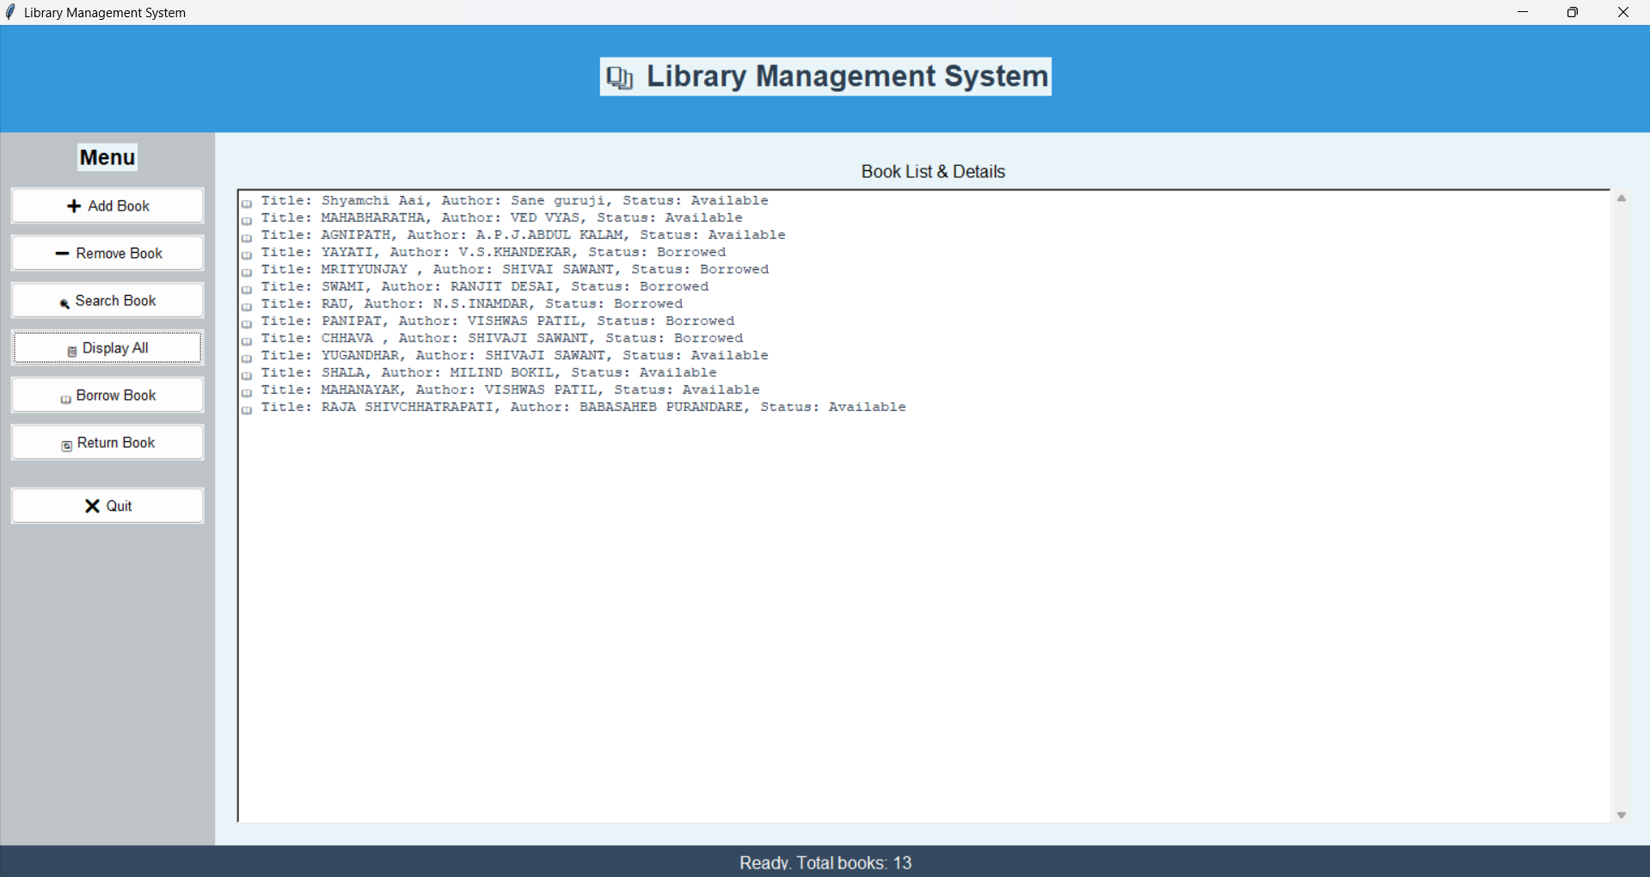
Display All view showing the complete list of 13 books with their current status (Available / Borrowed).

Success message confirming that the book 'YAYATI' has been returned successfully.

